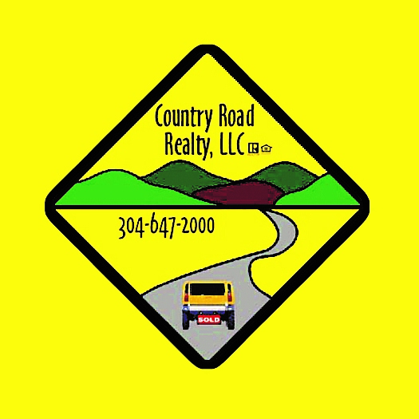

Why You Should Work With a REALTOR®

Not all real estate practitioners are REALTORS®. The term REALTOR® is a registered trademark that identifies a real estate professional who is a member of the NATIONAL ASSOCIATION of REALTORS® and subscribes to its strict Code of Ethics. Here are five reasons why it pays to work with a REALTOR®.

1. You’ll have an expert to guide you through the process. Buying or selling a home usually requires disclosure forms, inspection reports, mortgage documents, insurance policies, deeds, and multi-page settlement statements. A knowledgeable expert will help you prepare the best deal, and avoid delays or costly mistakes.

2. Get objective information and opinions. REALTORS® can provide local community information on utilities, zoning, schools, and more. They’ll also be able to provide objective information about each property. A professional will be able to help you answer these two important questions: Will the property provide the environment I want for a home or investment? Second, will the property have resale value when I am ready to sell?

3. Find the best property out there. Sometimes the property you are seeking is available but not actively advertised in the market, and it will take some investigation by your REALTOR® to find all available properties.

4. Benefit from their negotiating experience. There are many negotiating factors, including but not limited to price, financing, terms, date of possession, and inclusion or exclusion of repairs, furnishings, or equipment. In addition, the purchase agreement should provide a period of time for you to complete appropriate inspections and investigations of the property before you are bound to complete the purchase. Your agent can advise you as to which investigations and inspections are recommended or required.

5. Property marketing power. Real estate doesn’t sell due to advertising alone. In fact, a large share of real estate sales comes as the result of a practitioner’s contacts through previous clients, referrals, friends, and family. When a property is marketed with the help of a REALTOR®, you do not have to allow strangers into your home. Your REALTOR® will generally prescreen and accompany qualified prospects through your property.

6. Real estate has its own language. If you don’t know a CMA from a PUD, you can understand why it’s important to work with a professional who is immersed in the industry and knows the real estate language.

7. REALTORS® have done it before. Most people buy and sell only a few homes in a lifetime, usually with quite a few years in between each purchase. And even if you’ve done it before, laws and regulations change. REALTORS®, on the other hand, handle hundreds of real estate transactions over the course of their career. Having an expert on your side is critical.

8. Buying and selling is emotional. A home often symbolizes family, rest, and security — it’s not just four walls and a roof. Because of this, home buying and selling can be an emotional undertaking. And for most people, a home is the biggest purchase they’ll ever make. Having a concerned, but objective, third party helps you stay focused on both the emotional and financial issues most important to you.

9. Ethical treatment. Every member of the NATIONAL ASSOCIATION of REALTORS® makes a commitment to adhere to a strict Code of Ethics, which is based on professionalism and protection of the public. As a customer of a REALTOR®, you can expect honest and ethical treatment in all transaction-related matters. It is mandatory for REALTORS® to take the Code of Ethics orientation and they are also required to complete a refresher course every four years.

